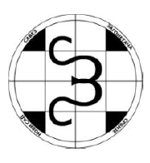
7th SERBIAN OPEN OPTIMIZING PUZZLE CHAMPIONSHIP
28. NOVEMBER - 08. DECEMBER 2014.
http://puzzleserbia.rs/

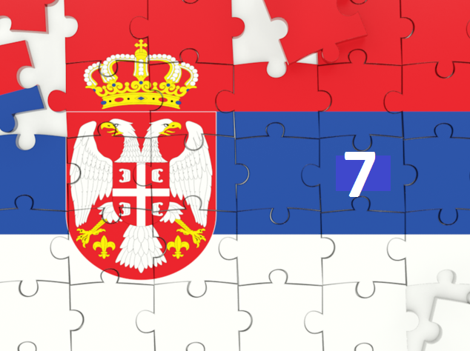

1. PENTOMINO-LETTERS
2. PENTO-TETRO-LOOP
3. PENTOMINO-AREAS

puzzle author: Zoran Tanasic

INTRODUCTION

7th Serbian open optimizing puzzle championship, as well as last year, consists of only one round and three independent puzzles that are scored separately. It will last 10 days.

PUZZLE 1. PENTOMINO - LETTERS

Place two complete sets of pentominoes in the given grid, without overlapping. Two same pentominoes can't touch each other, not even diagonally. Then, enter some words from the given list in the grid. All words should be entered from left to right or from top to bottom and each word can be used only once. Words can intersect and partially overlap and the same entered letters can touch each other only by side (they must not touch diagonally). All entered letters must belong to the properly entered words from the list.

Scoring: The length of each word is multiplied by the number of different pentominoes through which that word passes (when the word goes through the same two pentominoes, counted both). If the letter is written in the corresponding pentomino (pentomino with the same "name" as the letter) this letter brings additional 2 points. If the words intersect or overlap at such a letter, every word gets extra points. The field that contains only a letter or only pentomino, brings minus 3 points. Completely empty field brings minus 5 points. Maximize your score.

PUZZLE 2. PENTOMINO – TETROMINO - LOOP

Place 12 different pentominoes and 7 different tetrominoes in the given grid, without overlapping. They can't touch each other, even diagonally. Pentominoes can be rotated and reflected. Tetrominoes can be rotated but can't be reflected. Through the empty fields draw a closed line that connects the centers of the orthogonally adjacent fields and which don't intersect itself. Some fields may be left empty. All the fields within the loop, regardless of whether they are part of pentominoes/tetrominoes or not, must form a single orthogonally connected region.

Scoring: The length of the loop is multiplied by the total number of tetrominoes and pentominoes inside the loop. Each pentomino inside the loop brings negative 21 points. Each tetromino inside the loop brings negative 18 points. Each empty field inside the loop brings negative 11 points. Each pentomino outside the loop brings additional 6 points. Each tetromino outside the loop brings additional 5 points. Each empty field outside the loop brings negative 13 points. Maximize your score.

PUZZLE 3. PENTOMINO – AREAS

Divide the given grid into some regions by using some of the 6 given pentominoes: F, N, T, V, Y and Z. You don't have tu use all the given pentominoes, but you have to use 4 different pentominoes at least. Every used pentomino must be used at least 3 times. The same pentominoes can't touch each other by the side (diagonally touching is allowed). It is not allowed to completely cover any 2x2 area with pentominoes. A pentomino must not to separate two regions with the same size. The edge of the grid is considered to be the edge of the regions.

Scoring: Multiply the sizes of the regions. Maximize your score.

For all three puzzles competitor who achieves the highest score receives 25 points, then allocate 22, 19, 17, 15, 13, 11, 9, 7, 5, 4, 3 and 2 points, while all the other participants with the correct solution get 1 point. The winner becomes a contestant who gets the highest number of points. In the case of equal number of points, the better result in the second puzzle decides. In the case of equal result in the second puzzle, solutions sending time decides.
Note: be careful when you send your solutions. In the case that the solution does not fulfill any of the puzzle conditions, your score will be 0. You could scan your solutions or send them in a Word or Excel file. If you use the auxiliary tools for calculating your results, you can submit your score by copying the contents of the great white fields of auxiliary tools in the Word file. Write in your name, country and the results for each puzzle in the attached text. Send your solutions to email address answers@puzzleserbia.rs or zoran.tanasic@lipaks.rs not later than Monday, 08. December, 18:00 hours Central European Time. Good fun!

Instructions for using Utility for the first puzzle

ENTERING DATA
In the grid (when "Pentomino" is selected below), or in the "Pentomino" field
1, The first set of Pentominoes - upper case F, I, L, N, Q, T, U, V, W, X, Y, Z
2. The second set of pentominoes - lowercase letters f, i, l, n, p, t, u, v, w, x, y, z
3. The empty field - dot
In the grid (when "Words" is selected under it), or in the "WORDS" field
1. The words - in capital letters
2. Empty field – dot
For deleting contents of filed - enter space into it.

BUILT CONTROL
1. check for duplicated word
2. check if letter belongs to at least one word
3. check if the same letters touching diagonally
NOT BUILT CONTROL
1. Pentominoes shape
2. Which pentominoes are used
3. Check if same pentominoes touch each other (for example W and w)

Instructions for using Utility for the second puzzle

ENTERING DATA
In the grid (when "Tiles" is selected below), or in the "TILES" field
1. set of Pentominoes - upper case F, I, L, N, Q, T, U, V, W, X, Y, Z
2. set of Tetrominoes - lowercase ... i, j, k, n, o, s, t
3. The empty field - dot
In the grid (when "Loop" is selected below) or in the "LOOP" field
1. loop - lowercase l, r, u, d (left, right, up, down)
2. The inside of the loop - #
3. The empty field – dot
For deleting contents of filed - enter space into it.

NOT BUILT CONTROL
1. pentominoes /Tetrominoes shape
2. Which tiles are used
3. Check for touching
4. The connection of the internal field
5. The regularity of the loop (a closed line)

Instructions for using Utility for the third puzzle

ENTERING DATA
In the grid or in the input field
1. Pentomino - upper case F, N, T, V, Y, Z
2. empty field - dot
For deleting contents of filed - enter space into it.

BUILT CONTROL
1. 2 x 2 area
NOT BUILT CONTROL
1. Pentominoes shape
2. Which pentominoes are used (minimum 3)
3. Touch of edge the same pentominoes
4. whether the pentomino is boundary between two areas of the same size

EXAMPLES :

PUZZLE 1.

I | T | P | I | P | I |  |  | words | lenght word | Number different Pentominos | Corect letter in pentominos |  | Value | Result
L | O | R |  |  |  |  |  | KEPEC | 5 | 4 | 1 |  | 2 | 22
I | K | E | P | E | C |  |  | MINUS | 5 | 3 | 2 |  | 2 | 19
R |  | V |  |  | M |  |  | PEPSI | 5 | 3 | 3 |  | 2 | 21
I | P | E | P | S | I |  |  | PIPI | 4 | 3 | 2 |  | 2 | 16
S | R | S |  |  | N |  |  | PRA | 3 | 2 | 1 |  | 2 | 8
T | A | T | U |  | U |  |  | PREVESTI | 8 | 4 | 2 |  | 2 | 36
I |  | I |  |  | S |  |  | ILIRISTI | 8 | 2 | 4 |  | 2 | 24
 |  |  |  |  |  |  |  | TATU | 4 | 2 | 3 |  | 2 | 14
 |  |  |  |  |  |  |  | TOK | 3 | 2 | 1 |  | 2 | 8
 |  |  |  |  |  |  |  | RESULT 1 |  |  |  |  |  | 168
 |  |  |  |  |  |  |  |  |  | Number fields |  | Value |  | Result
 |  |  |  |  |  |  |  | Field only with letter |  | 2 |  | -3 |  | -6
 |  |  |  |  |  |  |  | Field only with pentominos |  | 11 |  | -3 |  | -33
 |  |  |  |  |  |  |  | Empty field |  | 1 |  | -5 |  | -5
 |  |  |  |  |  |  |  | RESULT 2 |  |  |  |  |  | -44
 |  |  |  |  |  |  |  | TOTAL |  |  |  |  |  | 124

PUZZLE 2.

 |  |  |  | 23 | 22 | 21 | 20 |  |  | Value | number pentomino and tetromino | Result
 | 37 | 36 | 35 | 24 |  |  | 19 |  | Lenght of loop | 46 | 4 | 184
 | 38 |  | 34 | 25 |  |  | 18 |  | Pentomino in the loop | -21 | 1 | -21
40 | 39 |  | 33 | 26 | 27 |  | 17 |  | Tetromino in the loop | -18 | 3 | -54
41 |  |  | 32 | 29 | 28 |  | 16 |  | Pentomino out of loop | 6 | 1 | 6
42 |  |  | 31 | 30 |  |  | 15 |  | Tetromino out of loop | 5 | 1 | 5
43 |  |  |  |  |  |  | 14 |  | Empty field in the loop | -11 | 5 | -55
44 |  |  | 5 | 6 | 7 | 8 | 13 |  | Empty field out of loop | -13 | 3 | -39
45 | 2 | 3 | 4 |  |  | 9 | 12
46 | 1 |  |  |  |  | 10 | 11 |  |  |  | TOTAL | 26

PUZZLE 3.

 |  |  |  |  |  |  |  | INCORRECT SITUATION
1 | 2 | 3
4 | 5 | 6 | 7 |  | 13 | 14
 |  |  |  | 12 | 15 | 16
1 | 2 | 3 |  | 11 | 17 | 18
4 | 5 |  |  | 10 |  | 19
6 | 7 |  | 8 | 9
8 | 9 |  |  | 7 |  | 9
10 |  | 2 | 3 | 6 |  | 8
 |  | 1 | 4 | 5 |  | 7
1 |  |  |  |  |  | 6 |  | Area value |  | 7 | 10 | 2 | 19 | 9
2 |  | 1 | 2 | 3 | 4 | 5 |  | TOTAL |  |  |  |  |  |  | 23940

PUZZLES

PUZLEE 1. (13 х12)

SET PENTOMINOES X 2

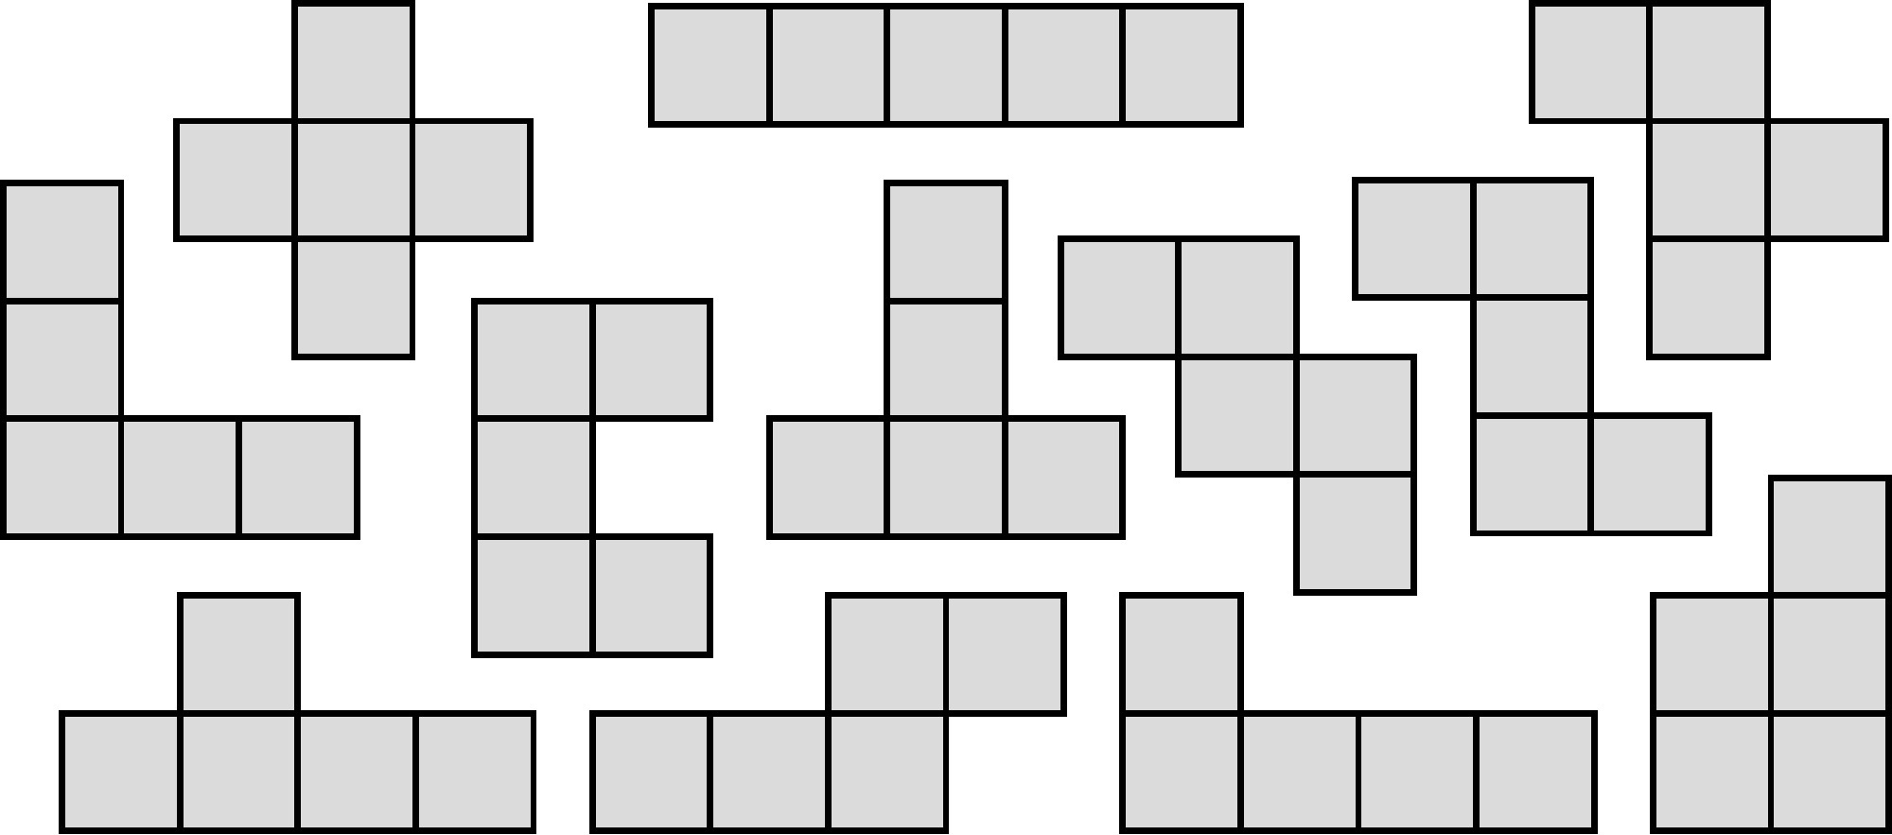

LIST of TERMS
ACTIVITY
APPLE
BUSY
CHALLENGE
CRAZY
DIFFERENT
DIFFICULT
EXHIBITION
EXIT
EXPLANATION
FANTASTIC
FAULT
FILLOMINO
FILTHY
FITNESS
FRUIT
FULL
FUNNY
HAPPINESS
HILL
HIPPY
HINT
INFINITY
INPUT
INSECT
INSELN
INTELLIGENT
INVITATION
LAWYER
LAZY
LINK
LITS
LITTLE
LOUDLY
LUCKY

MASYU
MISTERY
MIXTURE
NEW
NEXT
OFTEN
OPINION
OVERLAPPING
OVERVIEW
OWNER
PATIENT
PENTOMINO
PENTOPIA
PILLEN
PLAY
POPULAR
POSITIVE
PRETTY
PUNISH
PUSH
PUZZLE
SHIPPING
SIXTY
SLOWLY
SOLITARY
SOLUTION
SPINE
SPORT
SPY
STILL
STRIPPES
STUDY
STUPID
STYLE
STYLIST
SUBWAY
SURVIVE
TALENT
TAXI
TENNIS
TEXT
TOWEL
TOWN
TUTOR
TWELVE
TWENTY
TWIN
UNHAPPY
UNISEX
UNTIL
VANITY
VILLAGE
VILLAN
VISITOR
WILD
WINDOKU
WINDOW
WITNESS
WORRY
WORST
WUZZLE
YAJILIN
YINYANG
YOUTH
ZZZYXAS

PUZZLE 2. (17 х 17)

I |  |  | J |  | K |  |  | O
N |  |  | S |  |  | T

PUZZLE 3. (13 х 17)

