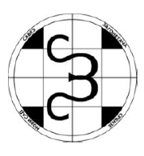
THE SIXTH SERBIAN OPEN CHAMPIONSHIP IN OPTIMIZERS
29th November - 8th December 2013.
http://puzzleserbia.com/

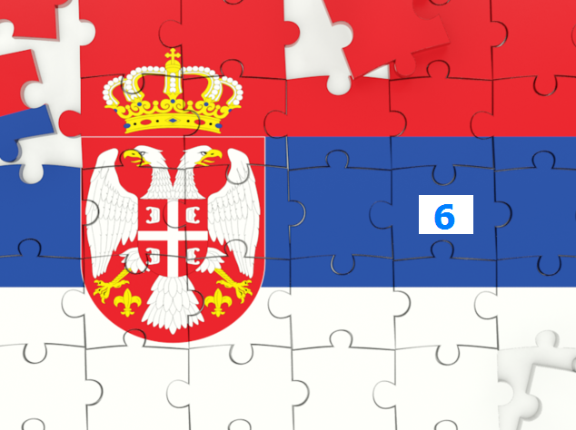

1. NANRO
2. MATHEMATICAL PENTOMINO
3. LETTER PAIRS

Author of the puzzles: Nikola Živanović
INTRODUCTION
The sixth Serbian championship in optimizers, unlike the preceding ones, consists of only one round and three puzzles which are scored separately. The first two puzzles are independent, while the third is a synthesis of the first two because some cells from the first two puzzles are transfered to the third.

PUZZLE 1 – NANRO
Place numbers in some cells so that no 2x2 area is completely filled with numbers. In each region there must be at least one number. All numbers within a region must equal to the number of filled cells in that region. Identical numbers from different regions must not be orthogonally adjacent. All numbered cells must be interconnected (like tapa).
Scoring: All cells filled with number different than 2 are worth 1 point. Maximize your score.

PUZZLE 2 – MATHEMATICAL PENTOMINO
Place all 12 different pentominoes in the grid so that the elements do not touch each other, not even diagonally. The pentominoes may be rotated and reflected.
Scoring: In each row and column multiply the lengths of sequences of connected white cells. If there is only one such sequence in a row (or column), the score for that row (or column) is the length of that sequence. The final score is the sum of the scores from all rows and colimns. Maximize your score.

Transfer:
In the half on the left hand side of the third puzzle (13x13) mark (shade) all the cells which are in the same position as the cells that have number 2 in the first puzzle. In the half on the right hand side mark (shade) all the cells which are in the same position as the cells that belong to pentominoes and are not at the edge of the grid.

PUZZLE 3 – LETTER PAIRS
Place some of the words from the list so that they do not cross or overlap. Each word can be used at most once. Ignore the blank space between the two words from the list. Words are to be written either across or down. The letter pair is formed whenever two identical letters appear in two orthogonally connected cells. It is not allowed to have a group of three or more identical letters in orthogonally connected cells.
Scoring: Each letter pair is worth 1 point. A letter pair that uses at least one shaded cell is worth 2 points. Maximize your score.

FINAL SCORING
For the first and the second puzzle, the contestant with the highest score gets 12, points, the next best get 10, 9, 8, 7, 6, 5, 4, 3, and 2 points, while all the other participants with a valid solution get 1 point. In the third puzzle the contestant with the highest score gets 18, points, the next best get 16, 14, 12, 10, 8, 6, 4, 3, and 2 points, while all the other participants with a valid solution get 1 point. The winner becomes the competitor that has the highest total score. In case of a tie, the winner is the contestant with the higher score on the third puzzle, and if it is still a tie, the winner is one that sent his or her solutions earlier.
Remark: We advise the competitors to be careful when sending solutions. If the solution is not valid it will score 0 points. You can either scan your solutions or create a file with grids where you will fill in numbers, letters and colours for marking pentominoes. In your email please write your name, country and score on each puzzle. Send your solutions to answers@puzzleserbia.rs till Sunday, December 8th, 10 PM, CET time. We wish you have a good fun!

Examples (on smaller grids and with three pentominoes):

PUZZLE 1
PUZZLE 2

 |  | 4 | 2 | 2 | 3
 |  |  | 1 |  | 3
1 | 4 | 4 | 4 |  | 3
3 |  | 2 |  | 3
 | 2 | 1 | 3 | 3 | 2
3 | 3 |  |  | 2
 |  |  |  |  |  | 3
 |  |  |  |  |  | 3
 |  |  |  |  |  | 1
 |  |  |  |  |  | 6
 |  |  |  |  |  | 3
 |  |  |  |  |  | 2
4 | 1 | 2 | 5 | 2 | 3

PUZZLE 3

APPLE
APRICOT
BANANA
CHERRY
GUAVA
LIME
ORANGE
PEACH
PEAR

 |  | А | P | P | L | E |  |  |  |  | O
 |  |  |  |  | P | E | A | C | H |  | R
P | E | A | R | A | P | R | I | C | O | T | A
 | B | A | N | A | N | A |  |  |  |  | N
 |  |  |  | G | U | A | V | A |  |  | G
 |  |  |  |  |  |  | L | I | M | E | E

PUZZLE 1
There are 22 filled numbers, out of which there are 6 twos. Your score is 16.

PUZZLE 2
The sum is: 3+3+1+6+3+2+4+1+2+5+2+3=35. Your score is 35.

PUZZLE 3
There are 8 letter pairs and 3 pairs use at least one shaded cell. Your score is 11.

PUZZLE 1
PUZZLE 2

PUZZLE 3

Pentominoes for the 2nd puzzle:

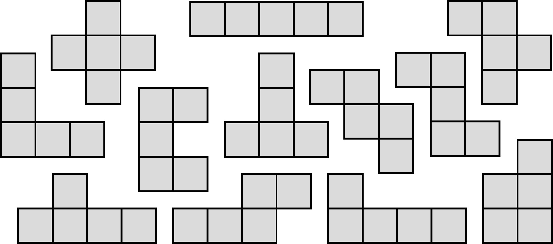

List of words for the 3rd puzzle:
(The United Nations (UN) has declared 2013 as the International Year of Water Cooperation)
AMAZONE
AMU DARYA
AMUR
ARKANSAS
BAIKAL
BAY OF BISCAY
BRAHMAPUTRA
COLORADO
CONGO
DANUBE
DNIEPER
DON
ERIE
EUPHRATES
GANGES
HURON
INDIAN OCEAN
IRTYSH
JEFFERSON
KAGERA
KAMA
LADOGA
LENA
LIMPOPO
LOIRE
MADEIRA
MALAWI
MEKONG
MICHIGAN
MISSISSIPPI
MISSOURI
MURRAY

NIGER
NILE
OB
OHIO
OKA
ONTARIO
ORANGE
ORINOCO
PARANA
PERSIAN GULF
PO
RED SEA
RHONE
RIO GRANDE
SAVA
SEINE
SUPERIOR
TANGANYIKA
TENNESSEE
THAMES
TIGRIS
TISA
TITICACA
TOBOL
URAL
VICTORIA
VOLGA
WINNIPEG
YANGTZE
YENISEI
YUKON
ZAMBEZI

